Practical No: 11
Aim: Implementation of Web Service for Arithmetic Operations.
Phase 1: Write the Web Service Code.
This code will act as the server hosting your web service endpoints.
1. Create a new folder on your Desktop named WebService_Lab.
2. Open Notepad or your IDE, and paste the following Python code.
3. Save the file as calculator_service.py.
Code:
from flask import Flask, request, jsonify
app = Flask(__name__)
@app.route('/')
def home():
return "Arithmetic Web Service is Running! Use /add or /divide endpoints."

# Endpoint 1: Addition
@app.route('/add', methods=['GET'])
def add_numbers():
try:
# Get parameters 'a' and 'b' from the URL
a = float(request.args.get('a'))
b = float(request.args.get('b'))
result = a + b

# Return the response in JSON format
return jsonify({
"operation": "addition",
"a": a,
"b": b,
"result": result
})
except (TypeError, ValueError):
return jsonify({
"error": "Please provide valid numbers for 'a' and 'b'."
}), 400

# Endpoint 2: Division
@app.route('/divide', methods=['GET'])
def divide_numbers():
try:
a = float(request.args.get('a'))
b = float(request.args.get('b'))
# Handle division by zero
if b == 0:
return jsonify({
"error": "Division by zero is not allowed."
}), 400

result = a / b
return jsonify({
"operation": "division",
"a": a,
"b": b,
"result": result
})
except (TypeError, ValueError):
return jsonify({
"error": "Please provide valid numbers for 'a' and 'b'."
}), 400
if __name__ == '__main__':
# Run the web service on port 8080
app.run(host='127.0.0.1', port=8080, debug=True)

Phase 2: Start the Web Service.
1. Open Command Prompt (cmd).
2. Navigate to your lab folder:
cd Desktop\WebService_Lab

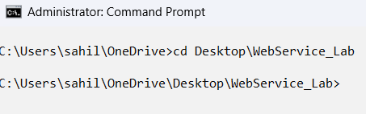
3. Run the Python script to start the service:
python calculator_service.py


(Leave this Command Prompt window open. The server is now listening for requests.)

Phase 3: Test the Web Service (The Client Output).
Because we used GET requests, you don't need any special client software like Postman to test this.
You can just use your standard web browser (Chrome, Edge, etc.).

Test 1: Addition.
(Open your browser and type this in URL)
http://127.0.0.1:5000/add?a=15&b=25.5
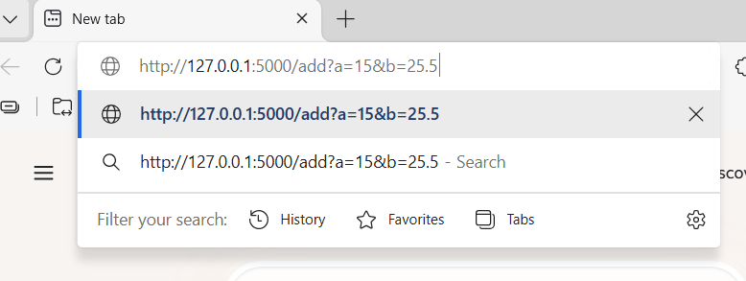
Output:
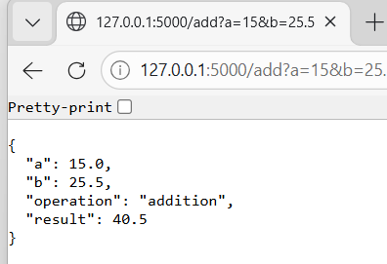
Test 2: Division.
(Open your browser and type this in URL)
http://127.0.0.1:5000/divide?a=100&b=4

Output:
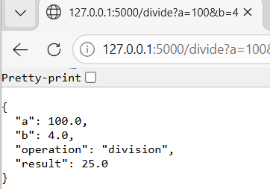

Test 3: Error handling (division by 0).
(Open your browser and type this in URL)
http://127.0.0.1:5000/divide?a=50&b=0

Output:
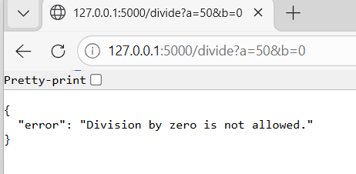

This demonstrates how a cloud service takes inputs, computes them on the backend, and returns a structured response that another application could easily read.

